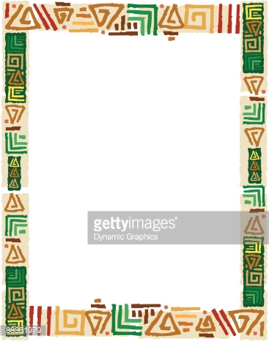

**As I Am**

As a young child growing up in my hometown of Monrovia, Liberia in West Africa, I knew that cooking was destined to play a major role in my adult life. With my grandmother as a constant companion, I learned the fundamentals of; womanhood, domesticity, discipline, spirituality, love, self-reliance, determination, faith and also a sense of humor. It was was very easy to be taught by “Mommie”, my grandmother, as I’m naturally creative. Cooking is one of the most important traditions for young Liberian girls who usually begin honing their skills by age ten. By the time I was eight, I have begun to collect different sizes of empty cans and create recipes from flowers and plants.

I recollect bringing cans of different flowers and plants to my grandmother and asking her to taste dishes I had created especially for her. Upon sampling my creations she would invariably respond by saying, “That so good! Where did you learn to cook like that?” I would simply reply, “It just came to me Mommie!”

My grandmother was gifted with powers of spiritual insight and envisioned that I would someday leave my homeland and practice my skills in a new country. I often recall how she held my hands very tightly, raised her head, closed her eyes and predicted, “I can see my baby in a strange land cooking to her heart’s content!” I, in turn, would march around her proudly singing, “Yes, I will be a cook someday.”

When I reached the age of ten (10), I began to officially learn the techniques of traditional Liberian cooking from my grandmother. My most vivid memories of those happy years as “Mommies apprentice” were her endless expressions and emotions about cooking.

My grandmother set on the porch about 50 feet from the kitchen, and instructed me how to cook. I was required to bring the pot to her each time I needed to add ingredients and stand at the pot the entire time the food was cooking. Her favorite byword was “you have to get to know your pot; you have to sense what stage your food is in by the smell.” Today it makes a great deal of sense to me. In addition to learning the “art of cooking” I can truly say that the most important lesson learned, is not being afraid to make my dreams a reality.

Now that I have discovered the most important part of my life, it is only the beginning… my dreams are endless! I am already envisioning my future dreams. My grandmother’s spirit dwells within me, and I pray daily that God will continue to bless me and keep her spirit alive. Thank you “Mommie”….

Always, Ma-Musu

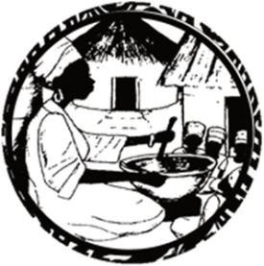

**Spicy Cassava Leaf (Liberia)**

**Cooked with Assorted Meat, served with white rice and sweet fried plantains**

**Spicy Potato Greens (Liberia)**

**Palm oil base, cooked with chicken & fish served with white rice and fried plantains**

**Egusi Soup (Nigeria)**

**Cooked with Assorted Meat served with pounded yams or white rice**

**Chicken Yassa (Senegal)**

**Mustard base Onions and Spices Cooked with chicken, served with white rice or couscous and sweet fried plantain**

**Chicken & Shrimp in Peanuts Stew (Guinea)**

**Chunks of chicken and shrimp slowly marinated in a spicy peanut stew, served with rice or fufu and sweet fried plantains**

**Palm Butter Stew (Liberia)**

**Cooked with Assorted Meats, served with white rice or fufu and sweet fried plantains**

**$14.95**

Chef Ma-Musu’s

West African Dishes